COMPILER DESIGN

- We can not have different Leftmost Derivation and Rightmost Derivation parse trees BUT we can certainly have different LMD and RMD for a given string.(LMD and RMD here refers to the order of various productions used for derivation which could be different.)
- Shift-reduce conflict: Yacc’s default action in the case of a shift-reduce conflict is to choose the shift action.
- Reduce-reduce conflict : Yacc’s default action in the case of a reduce-reduce conflict is to reduce using the production that comes first, textually, in the input grammar specification.
- A grammar which is LR(k) has to be Context Free.(LR grammars are subset of CFG)
- LR Parsers efficiently handle deterministic context-free languages(DCFL) in guaranteed linear time.All Regular Languages are also DCFL. Hence, they all can be parsed by a LR(1) grammar.
- For top down parsers, the grammar should be unambiguous, deterministic and should not be left recursive.All the 3 conditions must be satisfied for LL(1) parsers.Now, even if all 3 conditions are satisfied we cannot get an LL(1) or even LL(k) (for any k) grammar for even a DCFG. This is because there are DCFLs which do not have an LL(k) grammar. On the other hand, for any DCFL, we can always have an LR(1) grammar.
- YACC detects shift-reduce conflict, and resolves the conflict in favour of a shift over a reduce action
Shift-reduce conflict: Yacc’s default action in the case of a shift-reduce conflict is to choose the shift action.
Reduce-reduce conflict : Yacc’s default action in the case of a reduce-reduce conflict is to reduce using the production that comes first, textually, in the input grammar specification.
- It may be the case in the recursive decent parser with backtracking that a string belongs to the grammar but it is not parsed by the parser.
- Loader can perform linking.
- https://gateoverflow.in/386749/go-classes-test-series-2023-compiler-design-test-1-question
- https://gateoverflow.in/387353/go-classes-test-series-2023-compiler-design-test-2-question
- https://gateoverflow.in/387341/go-classes-test-series-2023-compiler-design-test-question-13
- https://gateoverflow.in/387337/go-classes-test-series-2023-compiler-design-test-question-15
- https://gateoverflow.in/387835/go-classes-test-series-2023-mock-gate-test-1-question-26
- https://gateoverflow.in/387810/go-classes-test-series-2023-mock-gate-test-1-question-39
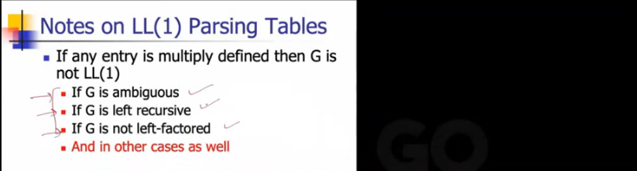
- Identifier names are unique.
- Cannot use a keyword as identifiers.
- Identifier has to begin with a letter or underscore (_).
- It should not contain white space.
- Special characters are not allowed.
- Identifiers can consist of only letters, digits, or underscore.
- Only 31 characters are significant.
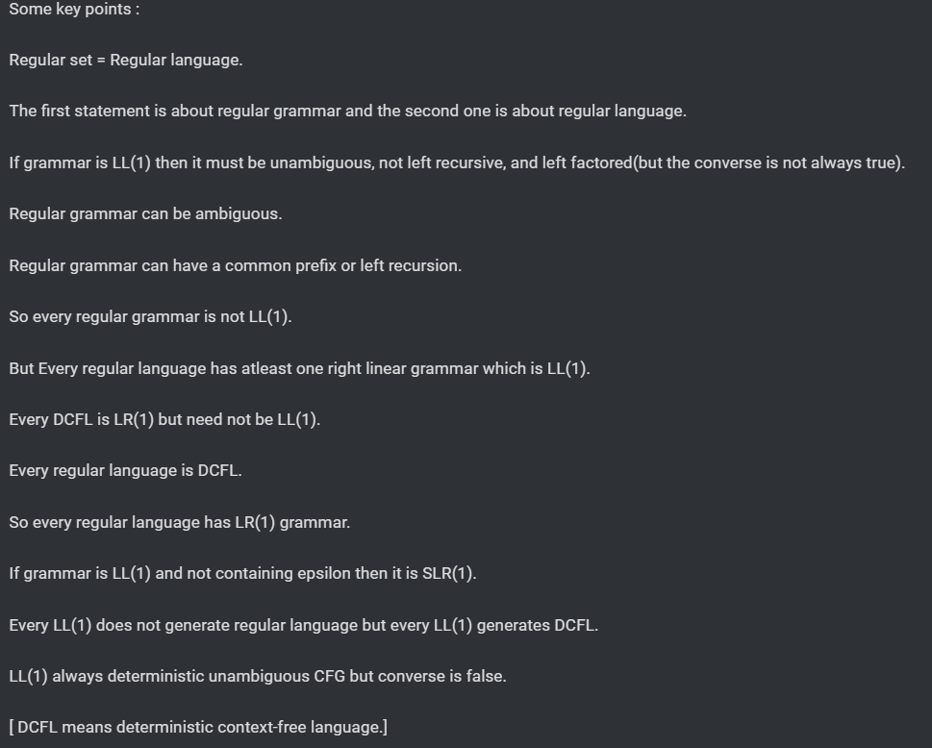

GATE CSE 2005 | Question: 59 - GATE Overflow for GATE CSE
Handles and Viable prefixes : https://www.youtube.com/watch?v=0q1BEXFUaBE https://www.geeksforgeeks.org/viable-prefix-in-bottom-up-parsing/

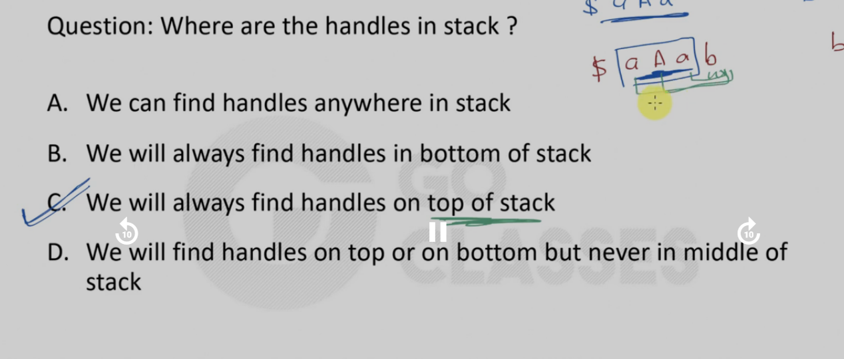
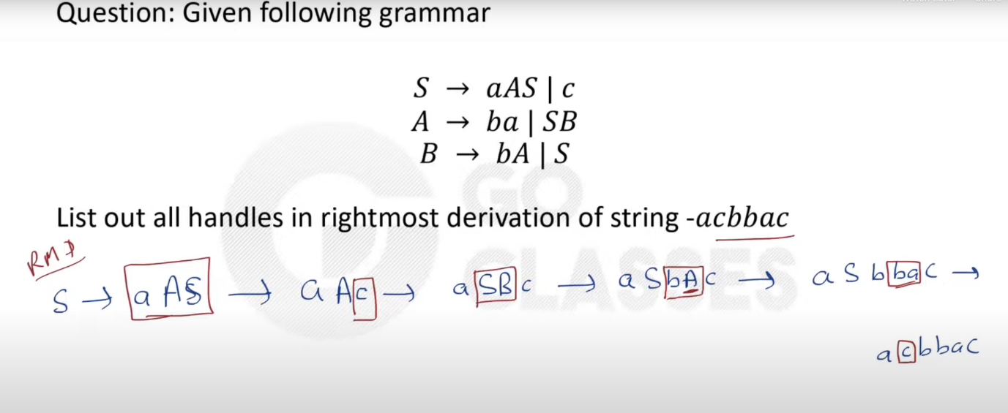
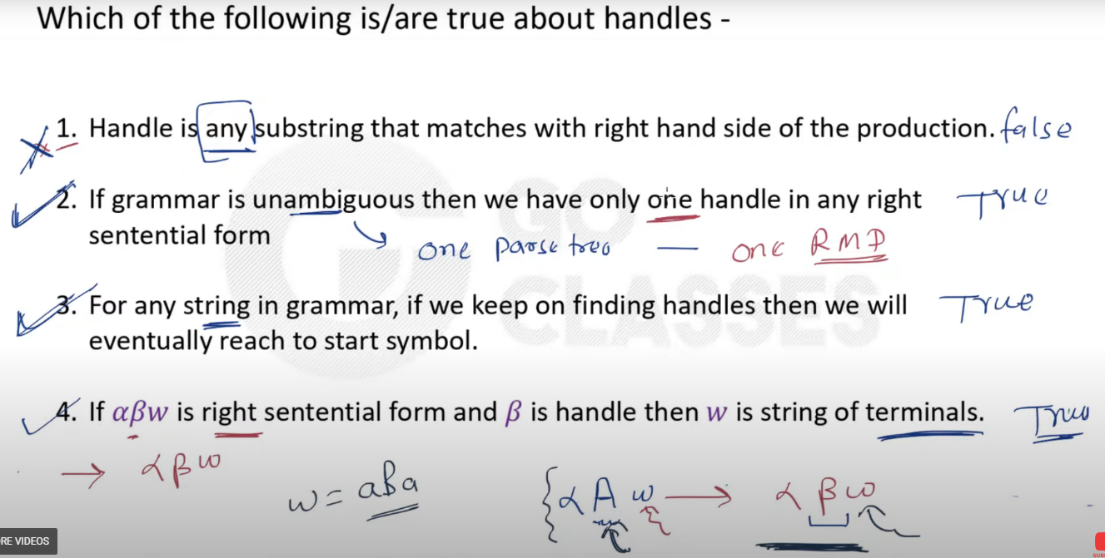
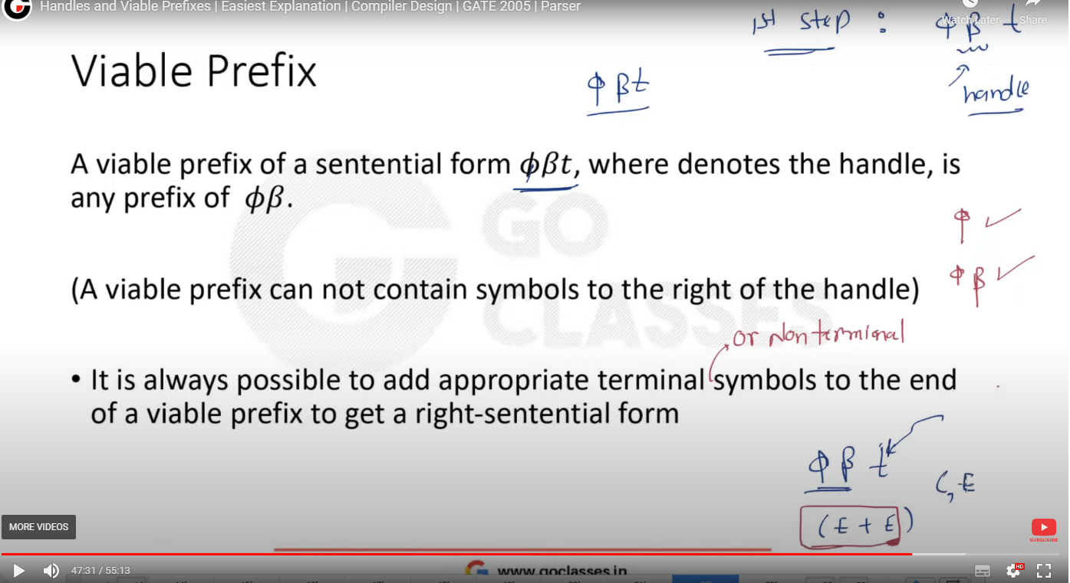
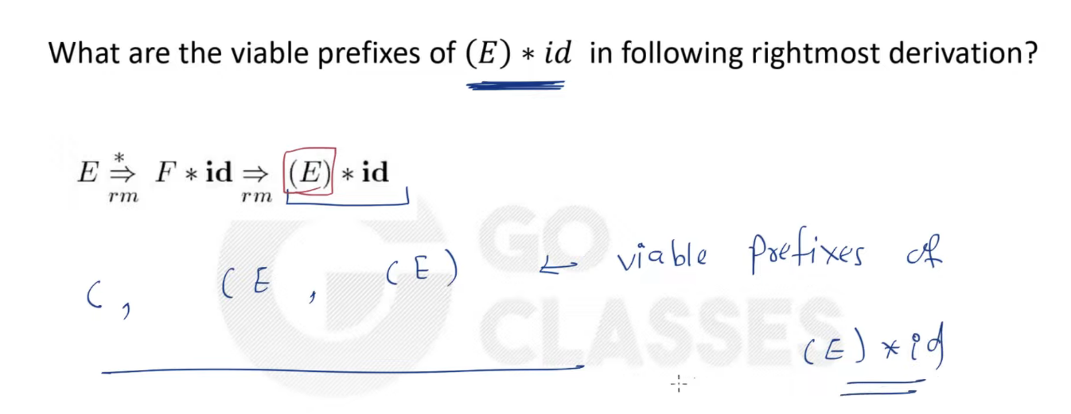
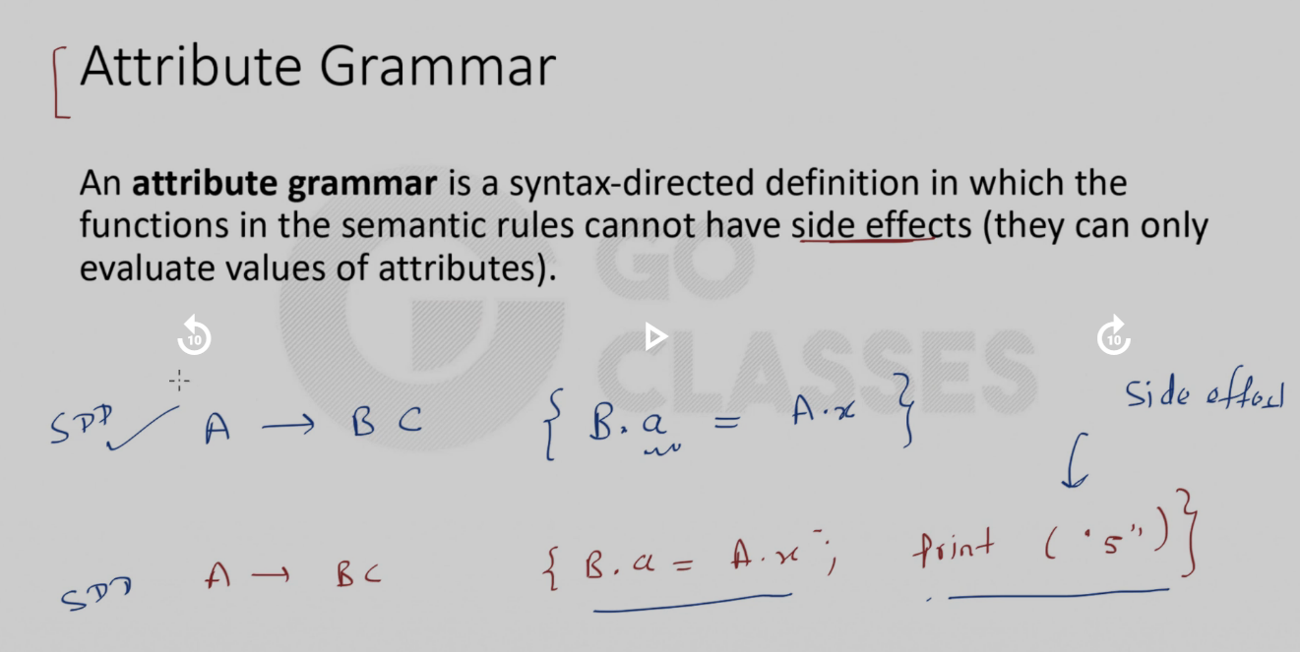
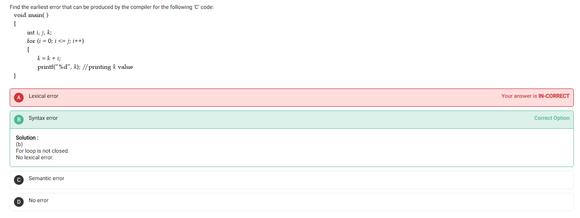
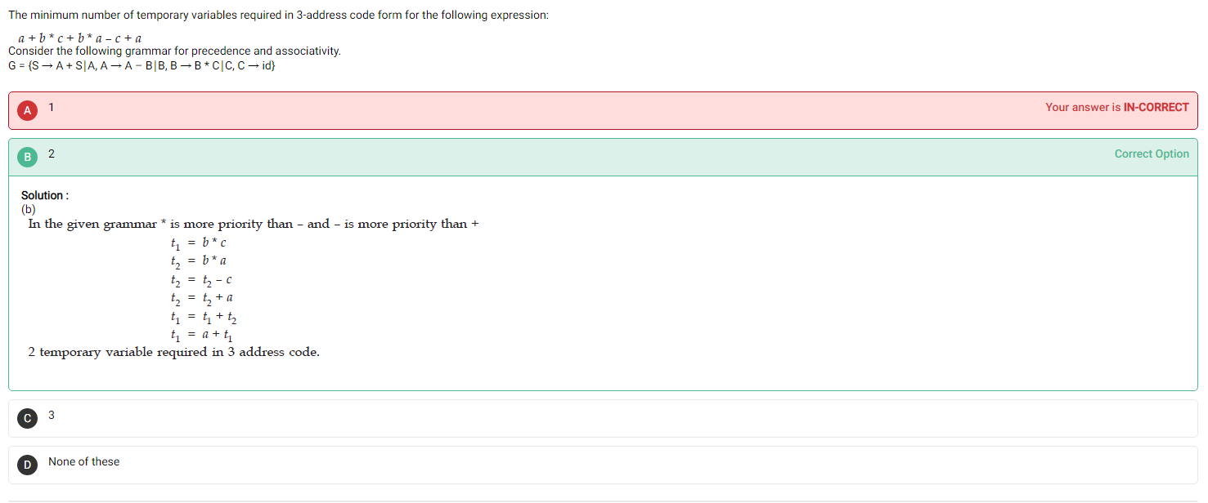

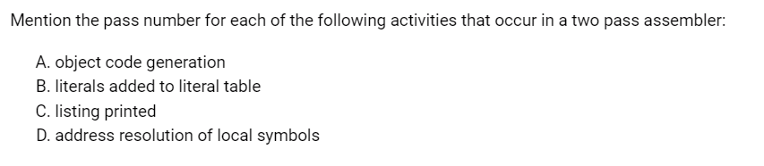

Tasks performed in 1st pass –
- Assign address to all statements (address resolution)
- Save the values
- Processing of assembler directives
- Table creation , Adding literals to literal table
- Allocate space for literals
- Compute total length of a program
Tasks performed in 2nd pass –
- Generate object oriented code
- Writing/printing assembly listing
- Generate code for all load and store instruction

READ THIS !!
Assembly process </head> (fiu.edu)
GATE CSE 1992 | Question: 03,ii - GATE Overflow for GATE CSE

Coroutine is just another name for a subroutine.
GATE CSE 1994 | Question: 17a - GATE Overflow for GATE CSE

A two pass assembler uses its machine opcode table in the first pass of assembly.
GATE CSE 1994 | Question: 17b - GATE Overflow for GATE CSE

A subroutine cannot always be used to replace a macro in an assembly language program. GATE CSE 1994 | Question: 18a - GATE Overflow for GATE CSE

A symbol declared as ‘external’ in an assembly language program is assigned an address outside the program. An assembler at the time of assembling has no information about the address of these extern symbols. It is the job of the linker to resolve them once assembling is over.
GATE CSE 1994 | Question: 18b - GATE Overflow for GATE CSE

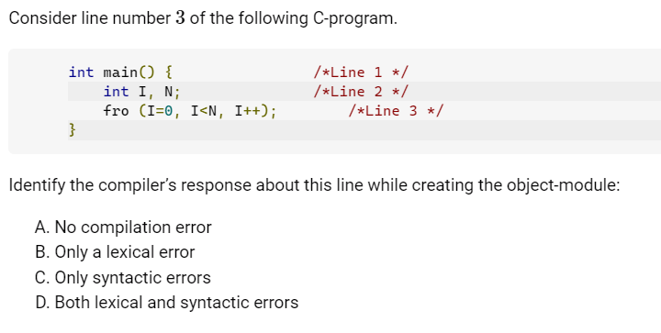GATE CSE 2005 | Question: 61 - GATE Overflow for GATE CSE

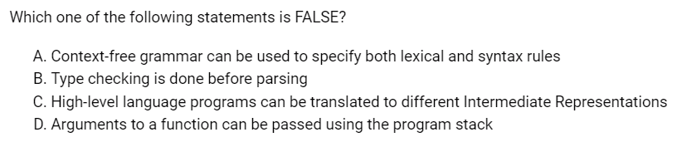GATE CSE 2018 | Question: 8 - GATE Overflow for GATE CSE

Debatable !!
GATE CSE 2021 Set 2 | Question: 3 - GATE Overflow for GATE CSE

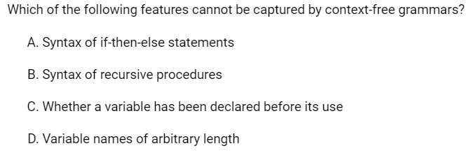GATE CSE 1994 | Question: 1.18 - GATE Overflow for GATE CSE

GATE CSE 1994 | Question: 3.5 - GATE Overflow for GATE CSE

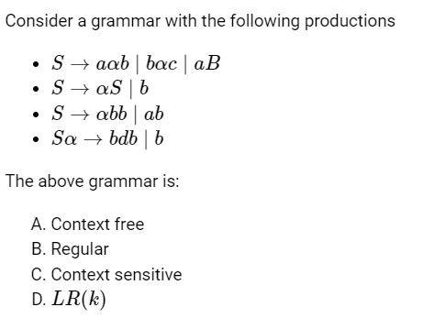

This question has all options wrong.
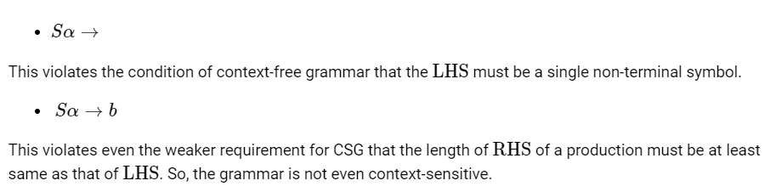A grammar which is LR(k) has to be Context Free.

So the grammar being unrestricted grammar (Type 0), is not context free (Type 2) and hence not even LR(k).

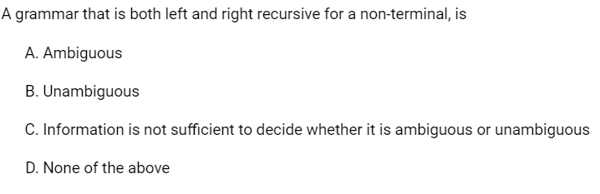
LOL 😂
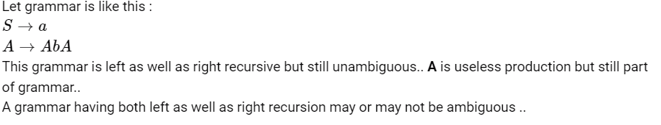GATE CSE 1999 | Question: 2.15 - GATE Overflow for GATE CSE

GATE CSE 2006 | Question: 32, ISRO2016-35 - GATE Overflow for GATE CSE

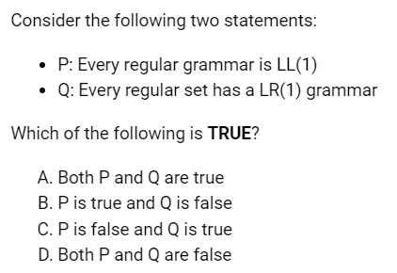
GATE CSE 2007 | Question: 53 - GATE Overflow for GATE CSE
LR Parsers efficiently handle deterministic context-free languages(DCFL) in guaranteed linear time.All Regular Languages are also DCFL. Hence, they all can be parsed by a LR(1) grammar.

GATE CSE 2007 | Question: 79 - GATE Overflow for GATE CSE

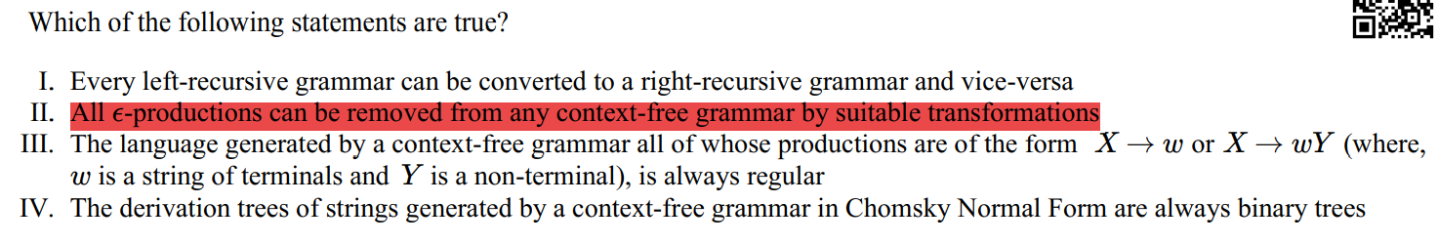
GATE CSE 2008 | Question: 50 - GATE Overflow for GATE CSE

GOOD QUESTION :
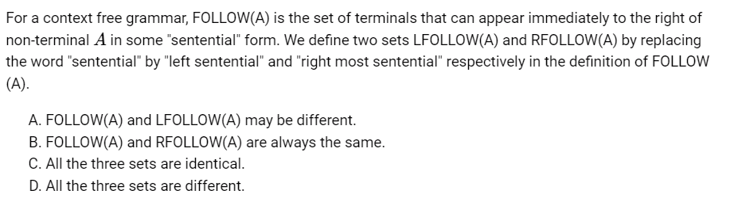GATE CSE 1992 | Question: 02,xiii - GATE Overflow for GATE CSE

See what is an error entry :
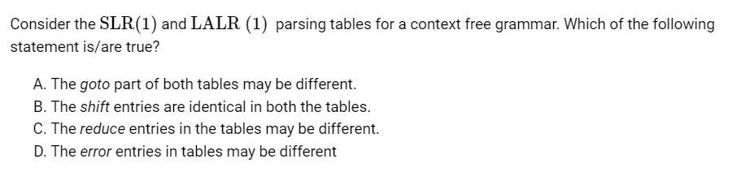
Error entries (kali dabbas in ll(1) table): Blank entries in table are treated as syntactical errors.
GATE CSE 1992 | Question: 02,xiv - GATE Overflow for GATE CSE

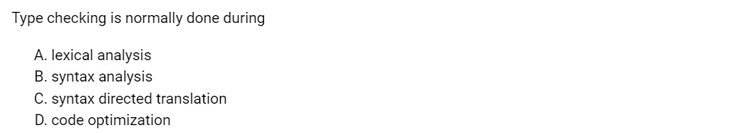
GATE CSE 1998 | Question: 1.27 - GATE Overflow for GATE CSE
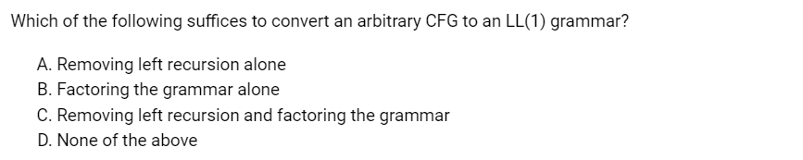
GATE CSE 2003 | Question: 16 - GATE Overflow for GATE CSE
For top down parsers, the grammar should be unambiguous, deterministic and should not be left recursive.All the 3 conditions must be satisfied for LL(1) parsers.
Now, even if all 3 conditions are satisfied we cannot get an LL(1) or even LL(k) (for any k) grammar for even a DCFG. This is because there are DCFLs which do not have an LL(k) grammar. On the other hand, for any DCFL, we can always have an LR(1) grammar.

What to choose, option A or B ?
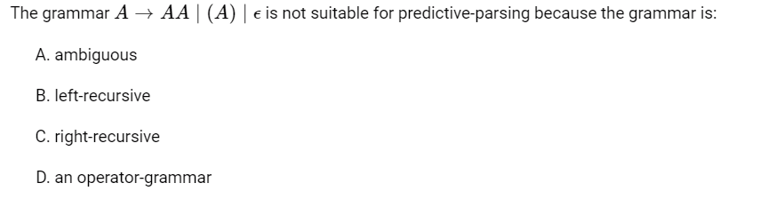
Option A is more stronger because we have standard procedure for removing left-recursion but ambiguity is not easy to remove.
GATE CSE 2005 | Question: 14 - GATE Overflow for GATE CSE

GOOD + TOUGH QUESTION
GATE CSE 2005 | Question: 83a - GATE Overflow for GATE CSE
GATE CSE 2005 | Question: 83b - GATE Overflow for GATE CSE
Shift-reduce conflict: Yacc’s default action in the case of a shift-reduce conflict is to choose the shift action.
Reduce-reduce conflict : Yacc’s default action in the case of a reduce-reduce conflict is to reduce using the production that comes first, textually, in the input grammar specification.

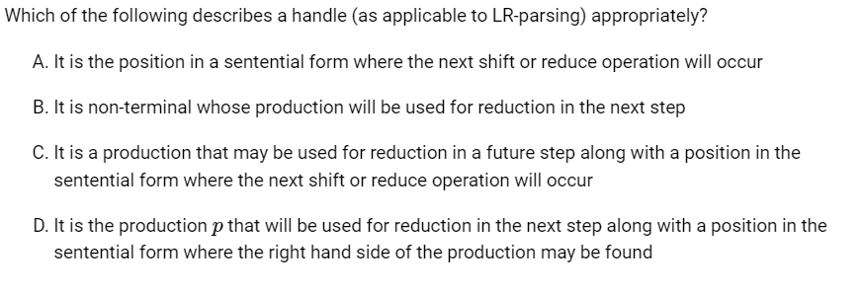GATE CSE 2008 | Question: 11 - GATE Overflow for GATE CSE

GATE CSE 2009 | Question: 42 - GATE Overflow for GATE CSE

Good question :
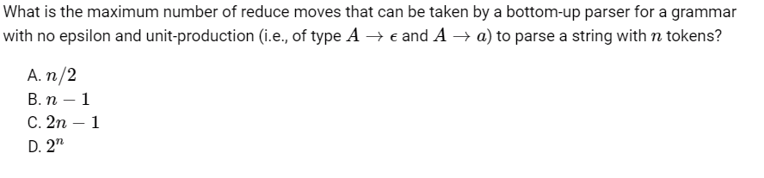
One thing to notice here is that it is not CNF grammar.
GATE CSE 2013 | Question: 9 - GATE Overflow for GATE CSE

Very good question :
GATE CSE 2017 Set 1 | Question: 43 - GATE Overflow for GATE CSE

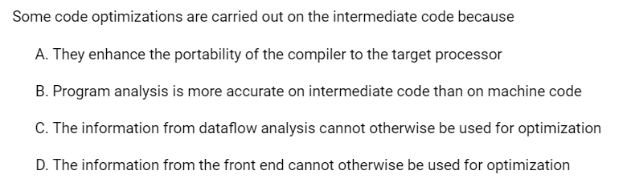

Answer: A
Option (B) is also true. But the main purpose of doing some code-optimization on intermediate code generation is to enhance the portability of the compiler to target processors. So Option A) is more suitable here. Intermediate code is machine/architecture independent code. So a compiler can optimize it without worrying about the architecture on which the code is going to execute (it may be the same or the other ). So that kind of compiler can be used by multiple different architectures. In contrast to that, suppose code optimization is done on target code, which is machine/architecture dependent, then the compiler has be specific about the optimizations on that kind of code. In this case the compiler can't be used by multiple different architectures, because the target code produced on different architectures would be different. Hence portability reduces here.
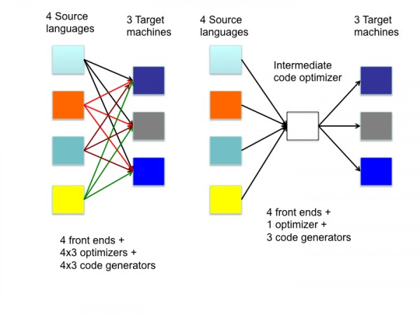

For finding minimum nodes and edges in DAG, you have to minimize the code first !
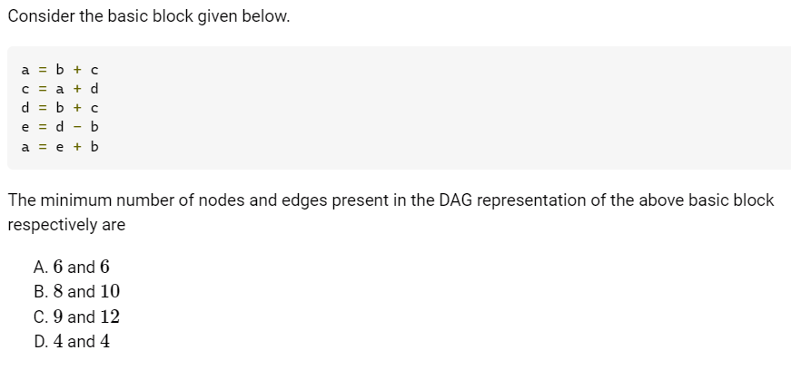
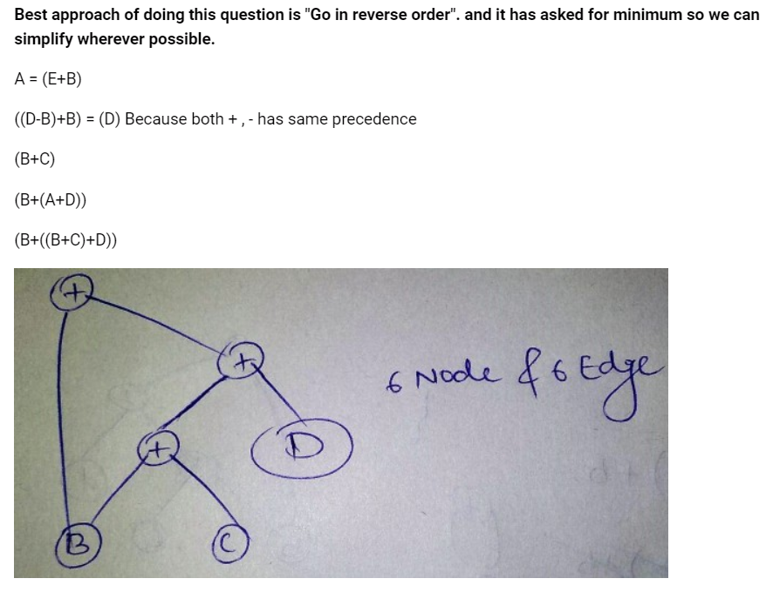

In this question, it doesn't asked for minimum edges and nodes so simply draw DAG without minimizing the code.
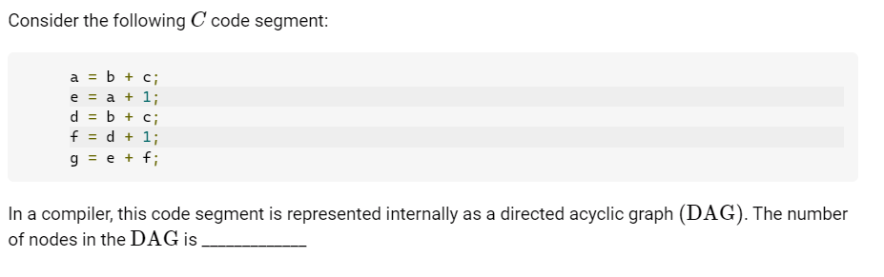GATE CSE 2021 Set 1 | Question: 50 - GATE Overflow for GATE CSE

SILLY MISTAKE : Forgot to count the additions in for loop variable incrementation.
GATE CSE 2021 Set 2 | Question: 30 - GATE Overflow for GATE CSE

New concept :
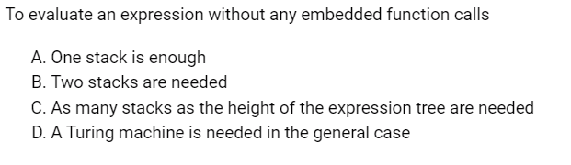First we can convert Infix to Postfix using single stack (Using it as operator stack).Then we can evaluate that expression using Single stack.
GATE CSE 2002 | Question: 2.19 - GATE Overflow for GATE CSE

GOOD QUESTION : GATE CSE 2014 Set 2 | Question: 39 - GATE Overflow for GATE CSE
GATE CSE 2014 Set 2 | Question: 34 - GATE Overflow for GATE CSE

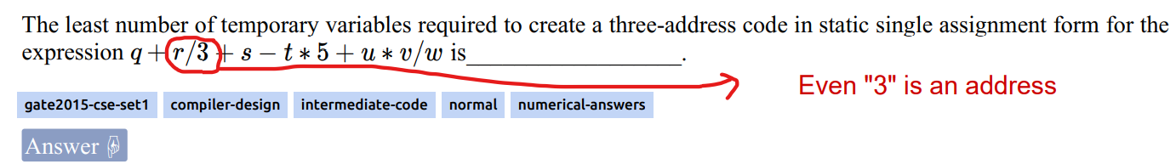GATE CSE 2015 Set 1 | Question: 55 - GATE Overflow for GATE CSE

Koi sense hai is baat ki ? 🙂
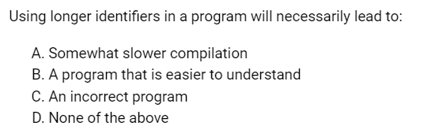
Option A) is Correct because lex will take more time to recognize the longer identifiers.
GATE CSE 1987 | Question: 1-xvii - GATE Overflow for GATE CSE

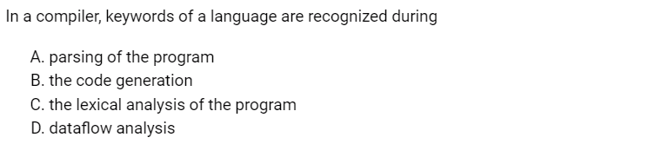GATE CSE 2011 | Question: 1 - GATE Overflow for GATE CSE

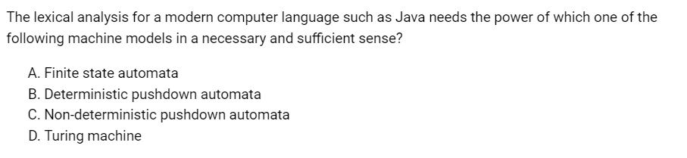Answer - A In compiler lexical analyzer categorises character sequence into lexemes and produces tokens as output for parser. And tokens are expressed in regular expressions so a simple Finite Automata is sufficient for it.
GATE CSE 2011 | Question: 19 - GATE Overflow for GATE CSE

GOOD QUESTION : GATE CSE 2018 | Question: 37 - GATE Overflow for GATE CSE

Ambiguous !
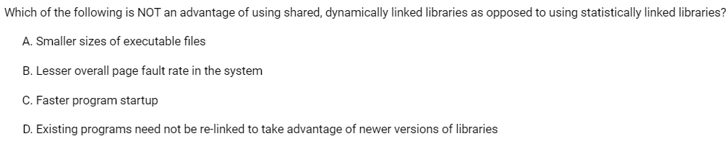GATE CSE 2003 | Question: 76 - GATE Overflow for GATE CSE

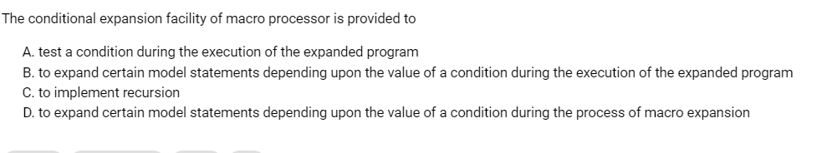
GATE CSE 1997 | Question: 1.9 - GATE Overflow for GATE CSE

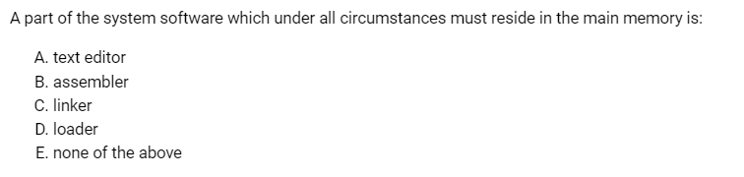Answer: D
The loader is a program that loads the object program from the secondary memory into the main memory for execution of the program. The loader resides in main memory.If loader is currently in the secondary memory, then who will load the loader into the main memory...because to do that we need loader. So loader is always in the main memory.

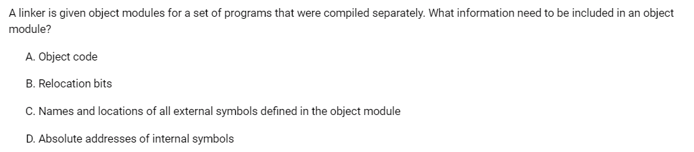GATE CSE 1995 | Question: 1.14 - GATE Overflow for GATE CSE

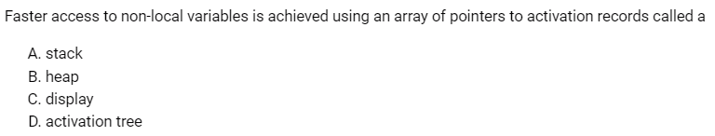
DISPLAYS : If a variable or a code or block or anything, that is not in my function but in other function, Then my function will use "access link" of Activation record to access them.Displays are an optimization technique that replaces access links. There are implemented as an array (of pointer) in this array each entry points to one of the activation records.The size of the array is the maximum nesting depth in the program
Use: if disp is the display, then disp[i] points to the activation record associated with the current
scope at nesting depth i.
Now if function j wants to access something that is in function i then
Step-1: go to the activation record pointed to by disp[i]
Step-2: find the nonlocal via an offset in this activation record

GATE CSE 2008 | Question: 54 - GATE Overflow for GATE CSE
Nice concept:
Programming languages which permit a function to return a function as its result cannot be implemented with a stack-based storage allocation scheme for activation records.Because once a function returns its activation record is no longer valid, so we cannot return a function as a result.

ACCESS LINKS : GATE CSE 2012 | Question: 36 - GATE Overflow for GATE CSE

GOOD QUESTION : GATE CSE 2019 | Question: 36 - GATE Overflow for GATE CSE
GATE CSE 2021 Set 1 | Question: 26 - GATE Overflow for GATE CSE
GATE CSE 1997 | Question: 4.9 - GATE Overflow for GATE CSE
GATE CSE 2010 | Question: 37 - GATE Overflow for GATE CSE

